Structures of important molecules

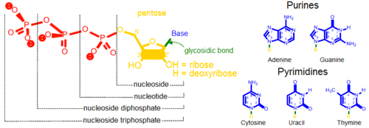

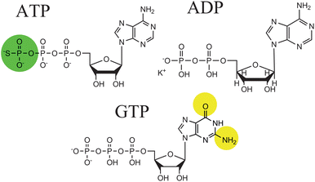

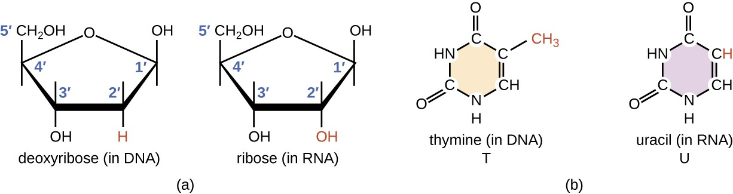

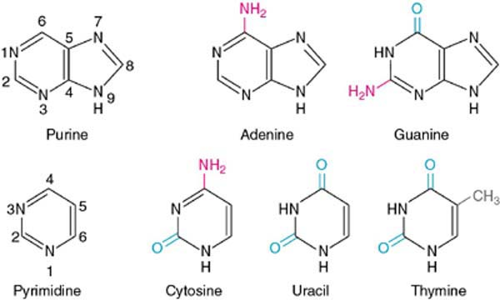

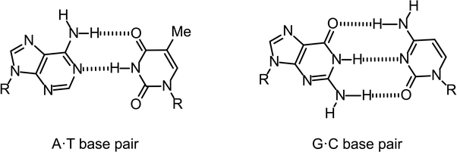

* Hydrogen bond acceptors are N and O (look at the possible hydrogen bonding)
  + Adenine contains 1 donor and 1 acceptor
  + Thymine contains 1 donor and 1 acceptor
  + Guanine contains 2 donors and 1 acceptor
  + Cytosine contains 1 donor and 2 acceptors

How to determine the effect of inhibitor on Vmax and Km?

* Keep the enzyme concentration constant, vary the substrate concentration and then include/ exclude the inhibitor
* Then conduct rate experiments by applying the principles of the Michaelis-Menten equation

How to effectively inhibit (uncompetitive) enzyme?

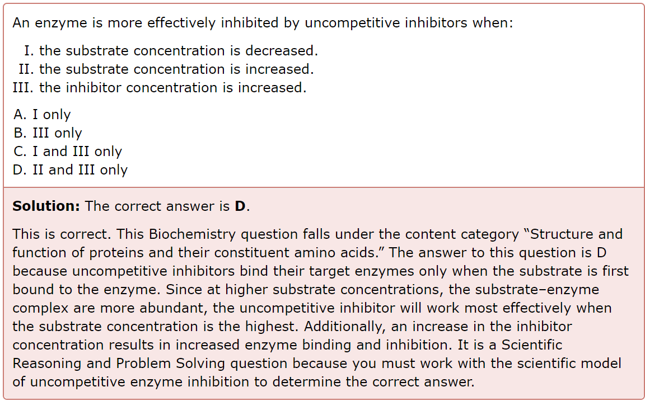

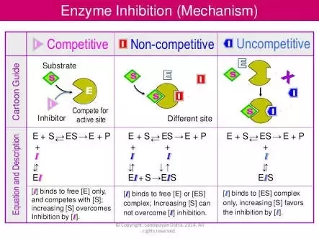

Weight of Amino Acid

* The average molecular weight of 1 amino acid = **110Da**
* Example
  + Integrase monomer has 288 amino acids
  + Total weight of monomer = 288 x 110Da = 32kDa
  + Total weight of tetramer = 4 x 32kDa = 128kDa

pI values of amino acid

* Higher pI → higher pKa → lower Ka → less acidic / more basic (referring to those positively charged amino acids at physiological pH e.g. arginine, lysine)

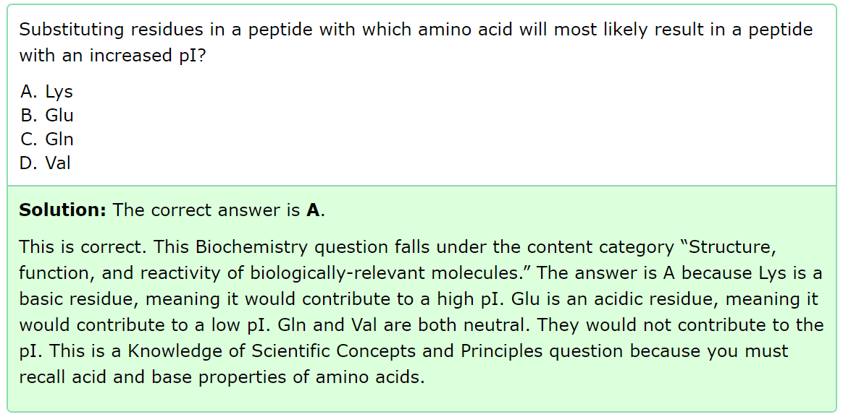

Catalytic Efficiency of Enzyme

* Efficiency = kcat / Km
* Where Vmax = kcat [E]
* kcat affects catalytic turnover while km affects substrate binding

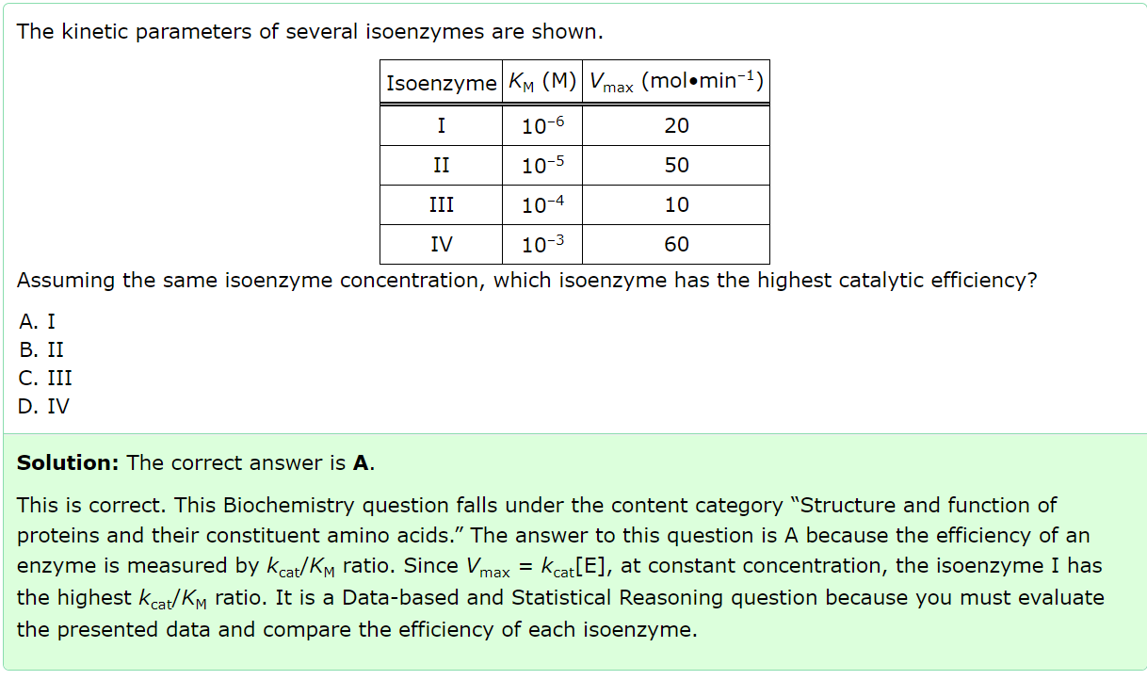

Constants related to affinity

* Dissociation constant kd
  + kd is a dissociation constant
  + Think of it like this [ES] ↔️ [S] + [E]
  + Hence, kd= [E][S] / [ES]
  + A lower kd value means a higher affinity for the enzyme (the components E and S are less likely to be separated, or ES is more likely to stay as a unit)
* Michaelis constant km
  + Concentration of substrate, [S], at 0.5 Vmax
  + In MCAT, kd and km are used interchangeably, though the kd is derived from km under special circumstances
* Affinity constant ka
  + The reciprocal of kd
  + ka = [ES] / [E][S]
* Apparent affinity constant kapp
  + The apparent affinity constant under the condition that you have a second substrate

Melting temperature, Tm

* *T*mis the temperature at which 50% of the molecules are denatured or the fraction folded is 0.5

Domains

1. Nuclear localization domain
   1. Tells the protein where it needs to go
   2. E.g. if it is a nuclear protein, it means that it requires a nuclear localization domain for nuclear translocation
2. DNA binding domain
   1. Binds to regulatory regions of targeted genes
   2. E.g. if it is a nuclear protein, it likely will bind to DNA in the nucleus in a later step
3. Protein binding domain
   1. Binds to some other proteins
   2. E.g. if the nuclear protein needs to interact with some other protein complex before it can be transported into the nucleus
4. Signal sequence domain
   1. Protein domains required for proteins that are directed toward secretory pathways
   2. E.g. a protein (not nuclear) that requires some other agent in the cell to carry it to the cell membrane

Gel Electrophoresis

* Native
  + In the absence of SDS
  + Proteins with smaller surface area (eg globular protein, thus less resistance) and lower molecular weight will migrate faster
* Reducing → disrupt any disulfide bonds
  + It is usually called Reducing SDS-PAGE
  + SDS does not reduce disulfide bonds, you need to add BME or some reducing agent
* Denaturing → disrupt interactions between monomers
  + It is usually called Denaturing SDS-PAGE
  + SDS is the denaturant, and will disrupt intrinsic protein charges and coat it with an overall negative charge, so each sample migrates **according to size only**

Disulfide bond

* It is a type of covalent bond (hence look out for **cysteine**)

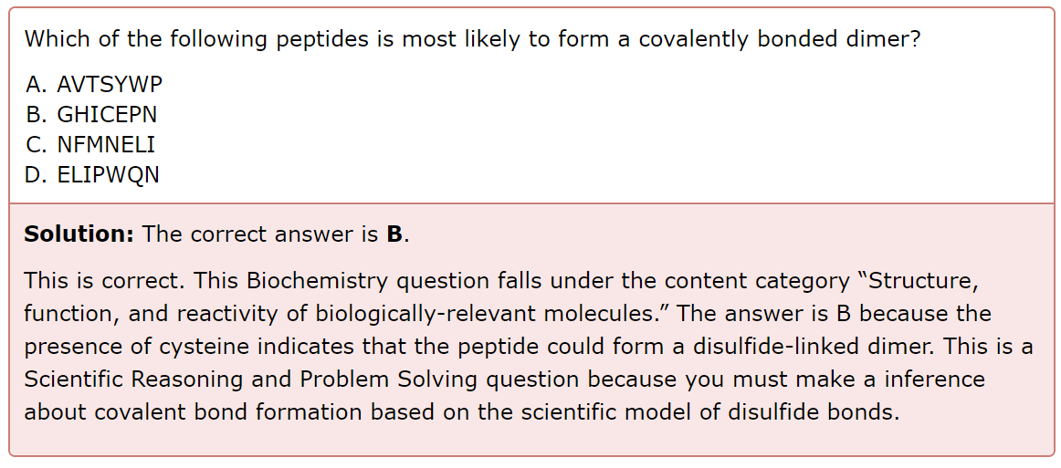

Hydrostatic Pressure vs Oncotic Pressure

* There is no oncotic pressure acting downwards (i.e. from blood in capillary to filtrate in bowman’s capsule) because proteins should not be able to flow across, which means that there is no protein in the filtrate (i.e. exerts no oncotic pressure)
  + Recall that oncotic pressure is like “sucking” pressure
* Therefore, the glomerular filtration rate is proportional to the glomerular capillary blood pressure minus the sum of the plasma osmotic pressure and the Bowman’s capsule hydrostatic pressure

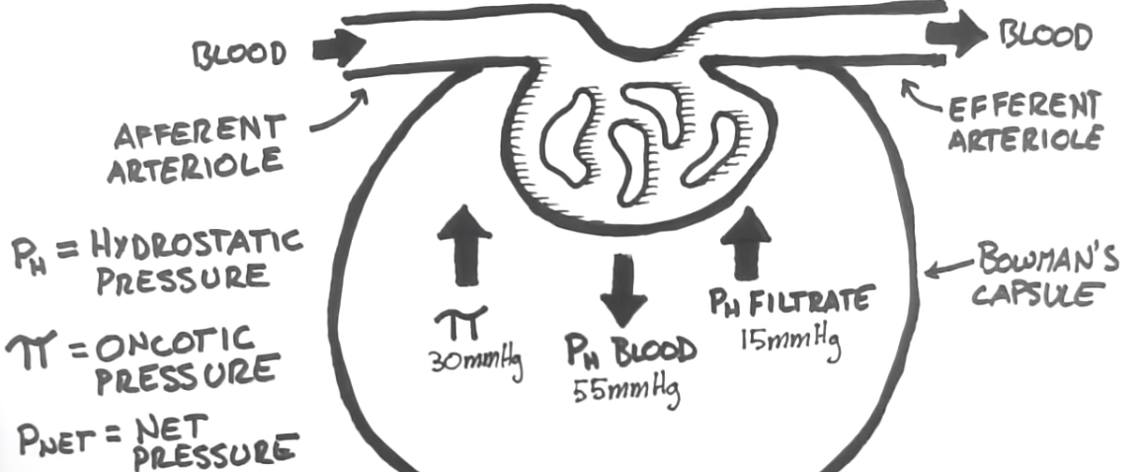

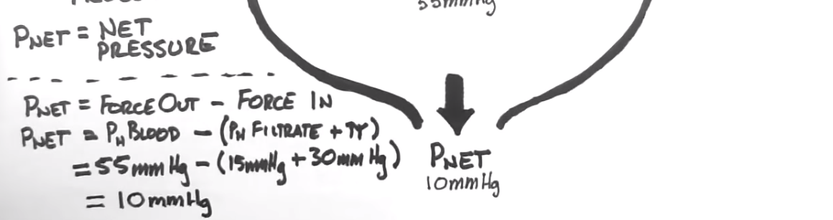

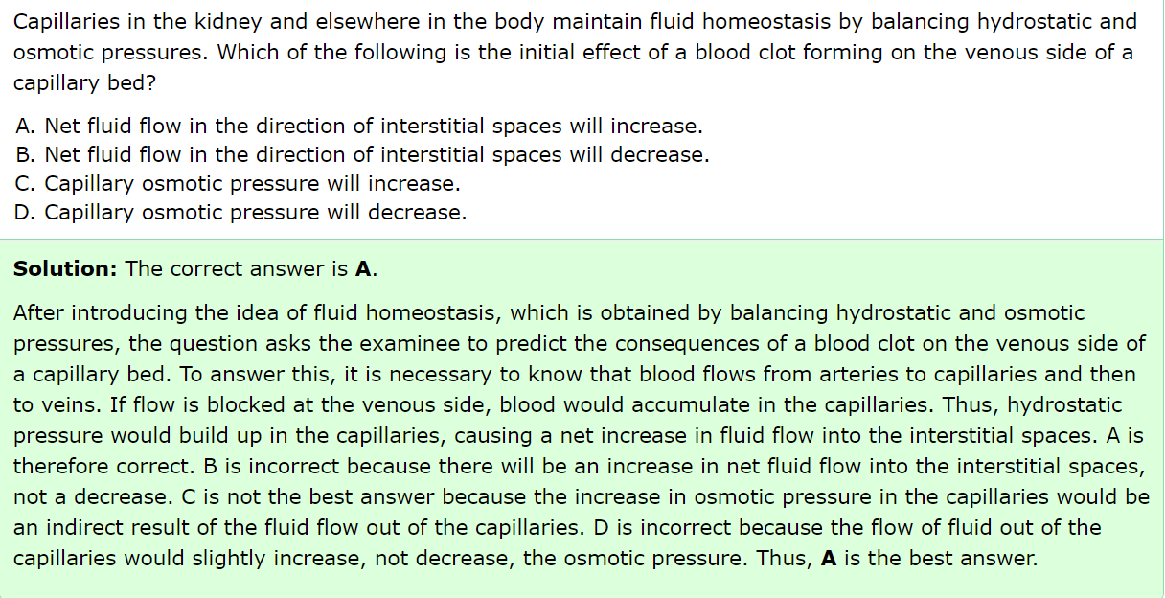

Non-dividing cells

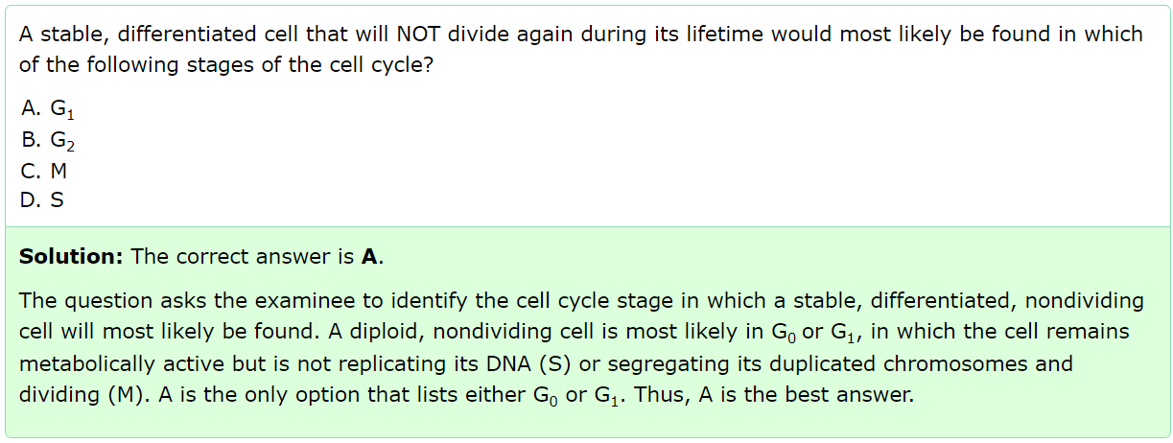

PCR

* Suitable primers have:
  + A high GC content
  + G or C base pairs at the 5’ and 3’ ends

Glucose

* The two epimers are:
  + D-mannose (C-2)
  + D-galactose (C-4)

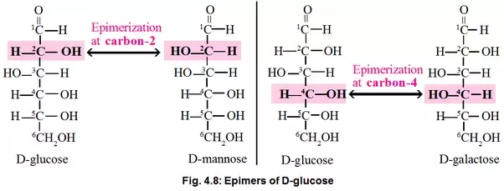

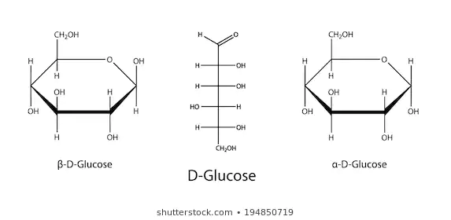

Reducing/ non-reducing sugars

* All monosaccharides are reducing sugars (e.g. glucose, fructose, galactose)
  + They have an aldehyde group (if they are aldoses) or can tautomerize in solution to form an aldehyde group (if they are ketoses)
* Some disaccharides are reducing sugars (e.g. maltose, galactose). Sucrose is **not** a reducing sugar.

Cholesterol

* Acts as a bidirectional regulator of membrane fluidity
  + At high temperatures, it stabilizes the membrane (decreases fluidity) and raises its melting point
  + At low temperatures, it intercalates between the phospholipids and prevents them from clustering together and stiffening (increases fluidity)

Metabolic states

1. Absorptive (just ate food, lots of glucose + insulin → anabolism)
   1. Glycogenesis (store glycogen in muscle and liver)
   2. Fat synthesis (store triglycerides in adipose tissue)
   3. Protein synthesis (store protein in the muscle)
2. Fasting (low blood glucose/ carbs → glucagon)
   1. Glycogenolysis (break down glycogen in the liver to make glucose to be delivered to other tissues)
   2. Glucogenesis (make glucose in the liver to be delivered to other tissues) using precursors:
      1. Fats in the adipose tissue → glycerol in the blood → Glycerol-3-phosphate in the liver → glucose in the liver
      2. Amino acid in the muscle → alanine in the blood → alanine in the liver → pyruvate in the liver → glucose in the liver
   3. Ketogenesis (make ketone bodies in the liver to be delivered to the muscle for energy production) using precursors:
      1. Fats in the adipose tissue → fatty acid in adipose tissue → fatty acid (with albumin) in the blood → fatty acid in the liver → acetyl-CoA in the liver → ketone bodies in the liver
   4. Ketolysis (happens in the muscle to form acetyl-CoA and hence ATP) using:
      1. Ketone bodies derived from ketogenesis in the liver
3. Starvation (no more glucose/ carbs; mainly rely on FA)
   1. Ketogenesis (make ketone bodies in the liver to be delivered to the muscle **and** **brain** for energy production)
   2. Ketolysis (happens in the muscle **and brain** to form acetyl-CoA and hence ATP)

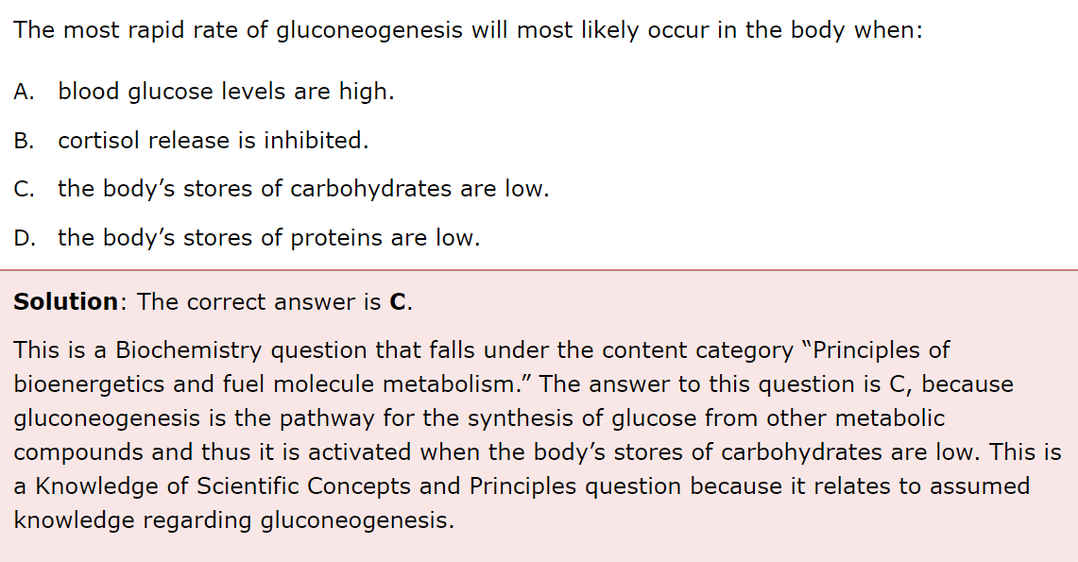

* D is incorrect because low protein indicates a starved state, sending the body into ketosis. At this point there are no carbs, and the liver converts FAs into ketones. Ketogenesis is the primary metabolic pathway at the point, and gluconeogenesis has failed.

Diabetes Mellitus

1. Type I (genetics; body is unable to produce insulin due to an autoimmune response directed against pancreatic β cells)
   1. Changing their insulin levels will not help
   2. Solution: Inject or secrete more glucagon, especially when blood glucose is low (prevents hypoglycemia)
2. Type II (body is unable to respond to insulin even though it often produces normal-to-elevated amounts of insulin)
   1. The body will try to find will alternative fuel sources e.g. catabolism of fatty acids and proteins for gluconeogenesis (this explains weight loss and fatigue even though the person is most likely obese) → increase blood glucose even more and worsens the condition further!
   2. Solution: Exercise more often so that the body uses up the glucose, or watch diet, or insulin therapy

Antibodies

* Say we have successfully tested that the antibody produced by the mouse works against a certain pathogen
* We still cannot use it on humans because our immune system will recognise the mouse antibody as a foreign substance (antigen), and instead generate antibodies against the mouse antibody

Vaccine Production

* Need to ensure these two conditions are fulfilled:
  + Immunogenicity: ability to induce a humoral and/or cell-mediated immune response (the person needs to generate new antibodies)
  + Toxicity: the antigens cannot possess any activity that might result in toxicity (the person should not be infected by the vaccines)

Nondisjunction

* Two possibilities:
  + Failure of homologous chromosomes to separate during anaphase I of meiosis
  + Failure of sister chromosomes to separate during anaphase II of meiosis

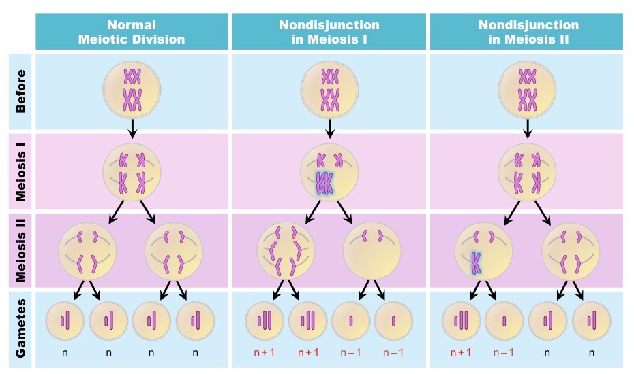

Tolerance

* Happens when:
  + The number of receptors on the postsynaptic neuron decreases
  + Strength of bond between drug and receptor decreases
  + The drug is metabolized too quickly (e.g. liver enzymes involved become more active)
* Hence, to achieve the same high effect you’re used to, you need to take increase your drug dosage